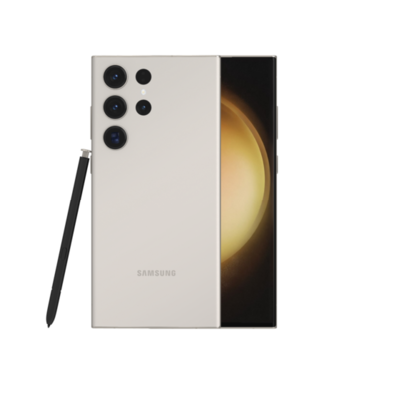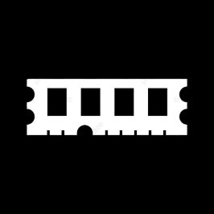

Price: $ 617.92

GALAXY S23 ULTRA

* Processor: Qualcomm SM8550-AC Snapdragon 8 Gen 2 (4 nm)
* Front Camera:12MP
* Rear Camera:200 MP
* Display:6.8 “
* NFC: Yes
* Colors: Phantom Black, Green, Cream, Lavender, Graphite, Sky Blue, Lime, Red

Operating System:

Android 13

* Charging Type:USB Type-C
* SIM: Nano-SIM and eSIM or Dual SIM
* Fingerprint:Yes
* Release Date: 2023, February 01

RAM

12

GB

ROM

01

TB

BATTERY

50000

mAh



+001-28272300-2466-2469



webmaster@cellinfo.com



A-65, ACME Co. ,

Street No. 12,

New York

Ask Me Ltd.